HONORS CHEMISTRY • UNIT 7
Gases
Explain gas behavior with moving particles, then predict how pressure, volume, temperature and moles change together.

TEACHER EDITION
Everything in a light-gray box, cell or line is an answer or model response. Teacher notes (misconceptions, interpretation choices, corrections) appear in the heavy-bordered boxes labeled TEACHER NOTE. The pages follow the student packet, so they line up closely.

TEACHER OVERVIEW
Numbering: the homework folder calls this “Unit 8 – Gases” (Worksheets #1–#4). This packet is Unit 7 in the notes sequence; topics 7.1–7.5 follow the worksheets in order (7.1–7.2 = WS #1, 7.3 = WS #2, 7.4 = WS #3, 7.5 = WS #4).
Answers are computed. Every numerical answer in the key was calculated by code using R = 0.0821 L·atm/(mol·K), K = °C + 273 and molar masses to 0.01 g/mol, then rounded to the sig figs of the data and proofread.
Homework quirks handled in the packet: the degree sign was lost in the PDF text of WS #2 (“450C”, “13 0C”, “67 0C”); these are read as 45 °C, 13 °C, 67 °C and so on. The WS #3 #4 particle picture must not be used for any calculation. WS #4 #1(d) gives ΔH per “mol rxn” – see the note in 7.5. Three extra conversions were added to 7.2 (d–f), each topic has a worked example and 1–2 multiple-choice items, and an Extra Practice page of new problems was written. Dalton’s law, density and STP are not in the homework and are not included.
Common misconceptions: using °C in a gas law; mixing pressure units with R; reading “inverse” as “negative”; believing pressure comes from the weight of the gas or from particles hitting each other; thinking collisions slow the particles down; forgetting the mole ratio in gas stoichiometry.

What we will learn
 | Topic
7.1 | Kinetic molecular theory & gas behavior
7.2 | Gas relationships & unit conversions
7.3 | The combined gas law
7.4 | The ideal gas law
7.5 | Gas stoichiometry

By the end of this unit I can…
• Use kinetic molecular theory to explain gas pressure, compressibility and elastic collisions.
• Sketch particle diagrams for a change in temperature, volume or number of particles.
• Decide whether two gas variables have a direct or an inverse relationship and explain why.
• Convert between pressure units (atm, torr, mmHg, kPa, psi) and between °C and kelvin.
• Solve combined gas law problems for any unknown, using kelvin temperatures.
• Use PV = nRT to find pressure, volume, moles, temperature or molar mass.
• Combine the ideal gas law with mole ratios to solve gas stoichiometry problems.

7.1 | Kinetic Molecular Theory & Gas Behavior Moving particles • elastic collisions • pressure • particle diagrams

BIG IDEA
A gas is a huge number of tiny particles flying around in mostly empty space. Everything we measure about a gas (pressure, volume, temperature) comes from how those particles move and hit things.

KINETIC MOLECULAR THEORY (KMT) — THE POSTULATES
1. Gas particles are tiny compared with the empty space between them.
2. Particles move constantly, in random, straight-line paths.
3. Particles do not attract or repel each other.
4. Collisions with each other and with the walls are perfectly elastic: no kinetic energy is lost.
5. The average kinetic energy of the particles is proportional to the Kelvin temperature.

Key vocabulary — write each definition in your own words
Term | Definition (your words) | Example / sketch
Elastic collision | What happens to the total kinetic energy when two particles collide?  Total kinetic energy is the same before and after: no energy is lost as heat or sound, so the particles keep moving. | Two particles bounce apart; their speeds change but the total energy does not.
Gas pressure | What causes it, and what does it act on?  Force of particle collisions with the walls of the container, divided by wall area. | Many hits per second on a wall.
Kelvin temperature | What is it proportional to? Why must we use it in gas laws?  Proportional to the average kinetic energy; 0 K is zero motion, so ratios and proportions work. | K = °C + 273

1. One of the postulates of KMT states that collisions are perfectly elastic. In your own words, describe what this means about the collision.
Particles bounce off each other and the walls without losing any kinetic energy; the energy is only passed between particles, so the gas never “run down.”

2. Gases are easily compressible whereas solids and liquids are not. Explain why.
Gas particles are very far apart (mostly empty space), so they can be pushed closer together. In solids and liquids the particles are already touching.

3. How does a gas create pressure on the surroundings?
Gas particles move constantly and collide with the walls of the container. Each collision exerts a tiny force; billions of collisions per second over the wall area give pressure.

4. A sample of gas is held in a sealed container, shown below.
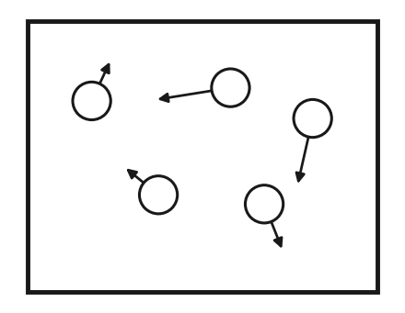 | a. What do the arrows indicate in the diagram?  Direction and speed of each particle’s motion.  b. Why are some arrows longer than others?  Longer arrow = faster particle (more kinetic energy). Particles in a gas move at a range of speeds; temperature measures the average.

c. Four boxes are provided below. Each box is a set of conditions changed from the original diagram. In each box, draw how the particles will look (use arrows to show speed).
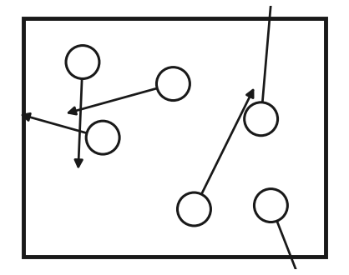 | 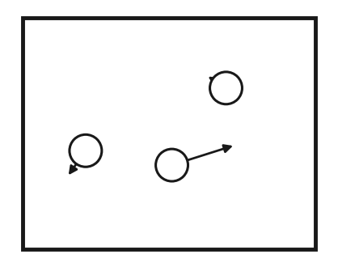 | 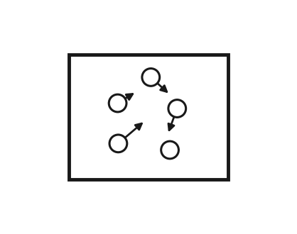 | 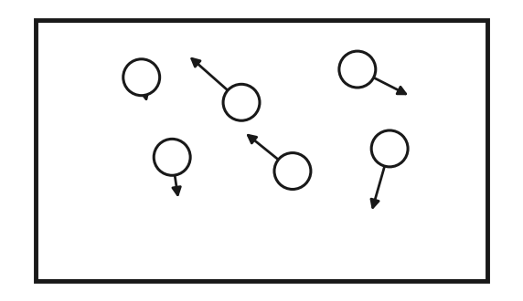
Same volume  Higher temperature  Same # of particles | Same volume  Same temperature  ½ the # of particles | Decrease volume  Same temperature  Same # of particles | Increase volume  Same temperature  Same # of particles

TEACHER NOTE
Sketches will vary. Look for: (1) same number of particles in the same box with longer arrows; (2) half as many particles, same arrow length, same box; (3) the same particles in a smaller box (closer together, more collisions per second); (4) the same particles in a larger box. Arrow length is speed, not force. Pressure is from collisions with the walls, not from the weight of the gas and not from particles hitting each other.

5. According to KMT, which statement is true for an ideal gas?
A) particles attract strongly B) collisions are perfectly elastic C) particles stop at 25 °C D) particles are touching
Answer: B — KMT postulate 4.
7.2 | Gas Relationships & Unit Conversions Pressure • volume • temperature • moles • direct vs inverse • kelvin

BIG IDEA
Four variables describe a gas: pressure (P), volume (V), temperature (T) and moles (n). Change one and the others respond. If two variables go up together the relationship is direct; if one goes up as the other goes down it is inverse.

Direct or inverse?
Variables | What stays the same? | Direct or inverse? | Explain with particles
a. Pressure vs Volume | T and n | Inverse | Smaller volume: particles hit the walls more often → higher pressure.
b. Pressure vs Temperature | V and n | Direct | Hotter: particles move faster, hit harder and more often → higher pressure.
c. Temperature vs Volume | P and n | Direct | Hotter gas must spread out (larger V) to keep the same pressure.
d. # Moles vs Pressure | V and T | Direct | More particles → more wall collisions → higher pressure.

CONVERSION FACTORS
1 atm = 760 torr = 760 mmHg = 101.3 kPa = 14.7 psi K = °C + 273
Set up each conversion as a fraction so the unit you start with cancels. Gas-law temperatures must be in kelvin, never °C.

Perform the conversion (show the fraction setup)
 | Convert | Work and answer (with units)
a. | 35.0 °C to kelvin | 35.0 + 273 = 308 K
b. | 1.25 atm to kPa | 1.25 atm × (101.3 kPa / 1 atm) = 127 kPa
c. | 38.0 psi to atm | 38.0 psi × (1 atm / 14.7 psi) = 2.59 atm
d. | 745 mmHg to atm | 745 mmHg × (1 atm / 760 mmHg) = 0.980 atm
e. | 202.6 kPa to psi | 202.6 kPa × (14.7 psi / 101.3 kPa) = 29.4 psi
f. | −25 °C to kelvin | −25 + 273 = 248 K

LAB CORNER • Sealed syringe

A syringe is sealed with 40 mL of air at 100 kPa. The plunger is pushed in slowly until the scale reads 20 mL. No air escapes and the temperature does not change.
1. (a) Predict the new pressure. (b) Use particles to explain why the pressure changed.
Answer:
(a) About 200 kPa: half the volume, double the pressure (inverse; P₁V₁ = P₂V₂).
(b) Same number of particles in half the space, so they hit the walls twice as often.

TEACHER NOTE
K = °C + 273 is used as on the homework (college courses use 273.15; answers differ in the 4th sig fig). “Direct” means both increase together (for P–T the graph is a straight line through the origin when T is in kelvin); “inverse” means the product stays constant. Do not let students call an inverse relationship “negative.”

1. As the temperature of a gas in a rigid, sealed container increases, the pressure…
A) decreases B) increases C) stays the same D) cannot be predicted
Answer: B
2. 2.00 atm is equal to how many mmHg?
A) 380 B) 760 C) 1520 D) 2000
Answer: C — 2.00 × 760 = 1520
7.3 | The Combined Gas Law P₁V₁/T₁ = P₂V₂/T₂ • always use kelvin

BIG IDEA
For a fixed amount of gas, PV/T stays constant. So when conditions change from state 1 to state 2: P₁V₁ / T₁ = P₂V₂ / T₂. Boyle’s, Charles’s and Gay-Lussac’s laws are this equation with the variable that does not change crossed out.

STEPS
1. List the givens in a table: P₁, V₁, T₁ and P₂, V₂, T₂ (one is the unknown).
2. Change every temperature to kelvin (°C + 273).
3. Write the equation, solve for the unknown, then substitute with units.
4. Check: does the answer make sense? (Higher T or lower P should make V larger.)

WORKED EXAMPLE
A sealed balloon holds 2.0 L at 1.0 atm and 27 °C. It is carried up a mountain where the pressure is 0.80 atm and the temperature is −3 °C. What is the new volume?

Work it out here:
T₁ = 27 + 273 = 300 K; T₂ = −3 + 273 = 270 K
V₂ = P₁V₁T₂ / (T₁P₂) = (1.0 atm)(2.0 L)(270 K) / [(300 K)(0.80 atm)] = 2.3 L
Check: pressure drops (V up) and temperature drops (V down); net is a slightly larger balloon.

Solve each problem. Show givens, equation, substitution and answer with units.
 | Combined gas law problems
1. | If I initially have a gas at a pressure of 11 atm, a volume of 23 liters and a temperature of 200 K, and then I raise the pressure to 13 atm and increase the temperature to 300 K, what is the new volume of the gas?  V₂ = P₁V₁T₂ / (T₁P₂) = (11)(23)(300) / [(200)(13)] = 29 L
2. | A gas takes up a volume of 18 liters, has a pressure of 2.3 atm and a temperature of 299 K. If I raise the temperature to 355 K and lower the pressure to 1.5 atm, what is the new volume of the gas?  V₂ = (2.3)(18)(355) / [(299)(1.5)] = 33 L
3. | A gas that has a volume of 31 liters, a temperature of 45 °C and an unknown pressure has its volume increased to 36 liters and its temperature decreased to 35 °C. If I measure the pressure after the change to be 2.0 atm, what was the original pressure of the gas?  T₁ = 318 K, T₂ = 308 K. P₁ = P₂V₂T₁ / (V₁T₂) = (2.0)(36)(318) / [(31)(308)] = 2.4 atm
4. | A gas has a temperature of 13 °C and a volume of 4.1 liters. Calculate the new temperature if the volume of the gas is reduced to 2.5 liters, assuming the pressure stays constant.  T₁ = 286 K. T₂ = T₁V₂ / V₁ = (286)(2.5) / 4.1 = 174 K (= −99 °C)
5. | If I have 18 liters of gas at a temperature of 67 °C and a pressure of 78.89 atm, what will be the pressure of the gas if I raise the temperature to 94 °C and decrease the volume to 12 liters?  T₁ = 340 K, T₂ = 367 K. P₂ = P₁V₁T₂ / (V₂T₁) = (78.89)(18)(367) / [(12)(340)] = 127.7 atm ≈ 1.3 × 10² atm

TEACHER NOTE — CORRECTIONS
In the PDF text of WS #2 the degree signs were lost (“450C,” “13 0C,” “67 0C”); the packet reads them as 45 °C, 13 °C, 67 °C and prints °C explicitly. #4 holds pressure constant, so it is Charles’s law; accept 174 K or −99 °C if the unit is given. #5 is limited to 2 sig figs by 18 L and 12 L, so 1.3 × 10² atm (128 atm) are both fine. Typical error: leaving a temperature in °C.

1. A gas at constant temperature is compressed from 4.0 L to 2.0 L. The pressure…
A) is halved B) doubles C) stays the same D) quadruples
Answer: B — P₁V₁ = P₂V₂
2. Which temperature scale must be used in every gas law calculation?
A) °C B) kelvin C) °F D) any, as long as it is consistent
Answer: B
7.4 | The Ideal Gas Law PV = nRT • choose R to match your units • molar mass

BIG IDEA
The combined gas law compares two states of a gas. The ideal gas law describes one state and adds the amount of gas: PV = nRT, where R is a constant. With it you can find any one of P, V, n or T.

Value of R | Use when P is in… | V in… / T in…
0.0821 L·atm / (mol·K) | atm | L / K
62.4 L·mmHg / (mol·K) | mmHg | L / K
8.31 L·kPa / (mol·K) | kPa | L / K

STEPS
1. Convert T to kelvin, V to liters, and P to the unit that matches your R.
2. Solve PV = nRT for the unknown (n = PV/RT, V = nRT/P …).
3. For grams: n = mass ÷ molar mass, so mass = n × M. For molar mass: M = mass ÷ n.
4. Answer with units and the right number of sig figs.

WORKED EXAMPLE
A 5.00 L tank holds nitrogen gas at 2.50 atm and 25 °C. (a) How many moles of N₂ are in the tank? (b) How many grams?

Work it out here:
(a) n = PV / RT = (2.50 atm)(5.00 L) / [(0.0821)(298 K)] = 0.511 mol
(b) mass = n × M = (0.511 mol)(28.02 g/mol) = 14.3 g

Solve each problem
 | Ideal gas law problems
1. | A typical human lung has a capacity of 3.90 liters. Assuming the lung has a pressure of 1.00 atm and a temperature of 40.0 °C, calculate the number of moles of gas present in a fully inflated lung.  n = PV / RT = (1.00)(3.90) / [(0.0821)(313)] = 0.152 mol
2. | A sample of nitrogen gas contains 0.921 moles at a pressure of 1.38 atm and a temperature of 316 K. What volume does this gas sample occupy?  V = nRT / P = (0.921)(0.0821)(316) / 1.38 = 17.3 L
3. | A sample of chlorine gas occupies a volume of 35.5 L at a pressure of 790 mmHg and a temperature of 100.0 °C. Calculate the number of grams of chlorine present in that sample.  P = 790 / 760 = 1.04 atm; T = 373 K. n = PV / RT = (1.04)(35.5) / [(0.0821)(373)] = 1.21 mol  mass = (1.21 mol)(70.90 g/mol) = 85.4 g Cl₂

4. A student obtains an unknown liquid, Substance A, that readily evaporates into a gas. The goal is to find the molar mass of the gas. The diagram shows the setup. (The particles only show that A has turned into a gas; do not count them in any calculation.)
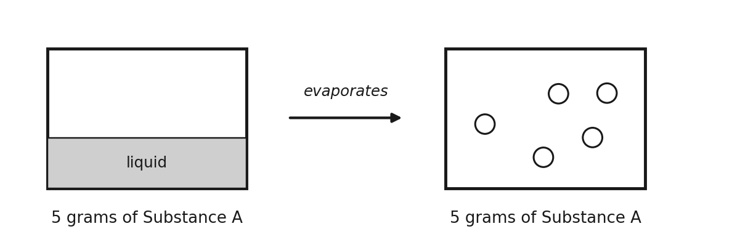
 | Parts a–e
a. | The liquid evaporates into the container. If all of it is now gas, how many grams of gas are present? Write your answer under the box that contains the gas.  5 grams (conservation of mass; the mass does not change when a liquid evaporates).
b. | What are the units of molar mass?  grams per mole (g/mol)
c. | The container has a volume of 5.00 liters and a temperature of 25.0 °C. The pressure produced by the gas is 1.25 atm. Calculate the number of moles of gas present.  n = PV / RT = (1.25)(5.00) / [(0.0821)(298)] = 0.255 mol
d. | Using the given information and your answer to part c, determine the molar mass of Substance A.  M = mass / n = 5.00 g / 0.255 mol = 19.6 g/mol
e. | The student repeats the experiment with 10.0 grams of Substance A. Do you expect the calculated molar mass to be higher, lower or the same as in part d? Explain.  The same. Twice the mass gives twice the moles (and twice the pressure at the same V and T), so mass ÷ moles is unchanged: molar mass is a property of the substance.

TEACHER NOTE
Choose R to match units: mmHg problems may use 62.4 instead of converting. T = 25.0 °C is 298 K here. In 4(e) students often say “higher” because the mass is larger; ask them what happens to n.

1. Which value of R is used when pressure is in atm and volume is in liters?
A) 62.4 B) 0.0821 C) 8.31 D) 22.4
Answer: B
7.5 | Gas Stoichiometry Grams → moles → (mole ratio) → moles → liters

BIG IDEA
Moles are the bridge. The balanced equation gives the mole ratio, and PV = nRT converts moles of gas into a volume (or a volume, pressure and temperature into moles).

ROAD MAP
grams of A → (÷ molar mass) → moles of A → (mole ratio from equation) → moles of B → (V = nRT / P) → liters of B
Going the other way: V, P, T of a gas → n = PV / RT → mole ratio → moles → grams (× molar mass).

WORKED EXAMPLE
Zn + 2HCl → ZnCl₂ + H₂. 3.27 g of zinc reacts completely. What volume of H₂ forms at 1.00 atm and 25 °C?

Work it out here:
3.27 g Zn × (1 mol / 65.38 g) = 0.0500 mol Zn; 1:1 ratio → 0.0500 mol H₂
V = nRT / P = (0.0500)(0.0821)(298) / 1.00 = 1.22 L H₂

1. Gasoline is mostly octane (C₈H₁₈), which burns in oxygen to give carbon dioxide and water.
 | Octane combustion
a. | Write the balanced chemical equation for the combustion of octane.  2C₈H₁₈ + 25O₂ → 16CO₂ + 18H₂O (or C₈H₁₈ + 12.5O₂ → 8CO₂ + 9H₂O)
b. | A gallon of gasoline has a mass of roughly 4000.0 grams. How many liters of CO₂ will be produced at 21.0 °C and 1.00 atm if 1 gallon of gasoline is combusted?  4000.0 g ÷ 114.23 g/mol = 35.017 mol C₈H₁₈ → × 8 = 280.14 mol CO₂  V = nRT / P = (280.14)(0.0821)(294) / 1.00 = 6762 L CO₂ (≈ 6.76 × 10³ L)
c. | Assuming the same temperature and pressure as part b, how many liters of oxygen gas are consumed?  mol O₂ = 35.017 × 12.5 = 437.71 mol; V = (437.71)(0.0821)(294) / 1.00 = 10600 L O₂ (≈ 1.06 × 10⁴ L)
d. | The enthalpy of combustion (ΔH) of octane is −5,460 kJ/mol rxn. Calculate the energy released in the combustion of 1 gallon of octane.  For the equation in (a) as written (2 octane = 1 mol rxn): 35.017 mol octane ÷ 2 = 17.509 mol rxn; 17.509 × 5,460 kJ = 9.56 × 10⁴ kJ released

2. A student performs the experiment below to collect the gas produced by the decomposition of sodium azide.
Reaction: ___ NaN₃(s) → ___ Na(s) + ___ N₂(g) 2, 2, 3
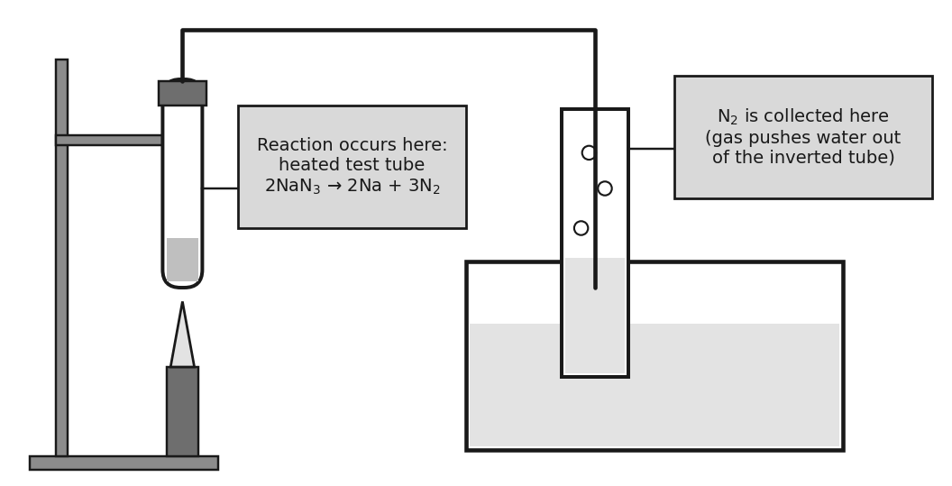
 | Sodium azide
a. | Label on the diagram where the reaction occurs and where the gas is collected (in the boxes).  See the labeled diagram above.
b. | Sodium azide is a solid at room temperature. Using your knowledge of types of compounds, explain why.  NaN₃ is ionic (a metal and a non-metal); strong electrostatic attractions between Na⁺ and N₃⁻ ions in a crystal lattice need a lot of energy to overcome, so it is a solid.
c. | 10.0 g of solid NaN₃ is decomposed and the gas collected. The pressure is 0.98 atm and the temperature is 32.0 °C. Calculate the volume, in mL, of N₂ produced.  10.0 g ÷ 65.01 g/mol = 0.154 mol NaN₃ → × 3/2 = 0.231 mol N₂  V = nRT / P = (0.231)(0.0821)(305) / 0.98 = 5.90 L = 5.9 × 10³ mL
d. | An airbag needs about 75.0 L of N₂ at 1.0 atm and 350 K. How many grams of NaN₃ must be decomposed?  n(N₂) = PV / RT = (1.0)(75.0) / [(0.0821)(350)] = 2.61 mol; × 2/3 = 1.74 mol NaN₃  mass = (1.74 mol)(65.01 g/mol) = 113 g NaN₃ (≈ 1.1 × 10² g)

TEACHER NOTE
1(d): “kJ/mol rxn” means per mole of the reaction as written. With 2C₈H₁₈ + 25O₂ → … one mole of reaction burns 2 mol octane, so 35.0 mol octane = 17.5 mol rxn → 9.56 × 10⁴ kJ. If a student balances with 1 octane (12.5 O₂) the number of moles of reaction doubles and the answer is 1.91 × 10⁵ kJ; discuss why the stated unit depends on how the equation is written. The water-vapor pressure of the collected gas is ignored in 2(c). Real airbags add KNO₃ so that the sodium metal is consumed.

1. The mole ratio used in a gas stoichiometry problem comes from…
A) the molar masses B) the coefficients of the balanced equation C) the ideal gas constant D) the subscripts in the formulas
Answer: B

PRACTICE
Extra Practice — Unit 7
Show your work. Kelvin always.

A. Which relationship? (name the law or equation you would use)
 | Situation | Law / equation
a. | A sealed syringe is pushed in; the temperature does not change. | Boyle: P₁V₁ = P₂V₂
b. | A balloon is placed in a freezer; the pressure stays the same. | Charles: V₁/T₁ = V₂/T₂
c. | A sealed aerosol can is heated. | Gay-Lussac: P₁/T₁ = P₂/T₂
d. | Gas is pumped into a rigid tank; find the moles added. | Ideal gas law: PV = nRT

B. Calculate
 | Problems
a. | A 6.50 L sample of gas at 1.20 atm and 25 °C is compressed to 2.00 L while heated to 60 °C. What is the new pressure?  P₂ = (1.20)(6.50)(333) / [(298)(2.00)] = 4.36 atm
b. | How many grams of CO₂ are in a 2.50 L tank at 3.00 atm and 27 °C?  n = (3.00)(2.50) / [(0.0821)(300)] = 0.305 mol; × 44.01 g/mol = 13.4 g
c. | CaCO₃ → CaO + CO₂. What volume of CO₂ forms at 1.00 atm and 25 °C when 5.00 g of CaCO₃ decomposes?  5.00 g ÷ 100.09 = 0.0500 mol → V = (0.0500)(0.0821)(298) / 1.00 = 1.22 L

C. Gas data
A student traps air in a syringe at constant temperature and records the pressure as the volume changes. Complete the table, then plot V (y-axis) against P (x-axis).
1. What is the relationship between P and V?  Inverse: P × V is constant (12 atm·L). | 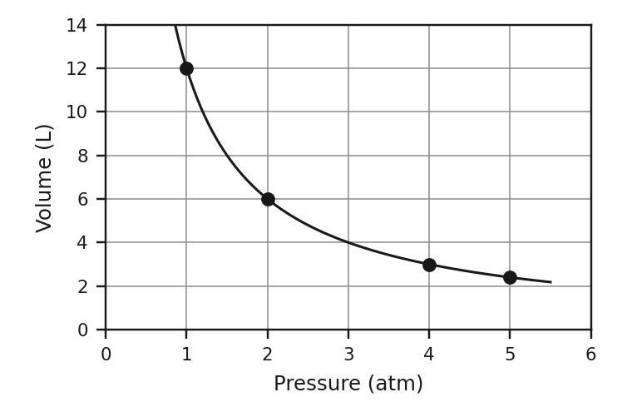
  P (atm) | V (L) | P × V
  1.0 | 12.0 | 12
  2.0 | 6.0 | 12
  4.0 | 3.0 | 12
  5.0 | 2.4 | 12

D. Think
1. Explain with particles why a sealed can of spray paint says “do not store near heat.”
Heating raises the average kinetic energy: particles move faster and hit the walls harder and more often. The volume cannot change, so pressure rises and the can may burst.

2. Which gas sample has more particles: 2.0 L at 1.0 atm and 300 K, or 2.0 L at 1.0 atm and 600 K? Explain.
The 300 K sample. At the same P and V, n = PV/RT, so doubling T halves n: the hotter gas has half as many particles.

3. At constant pressure, a gas at 300 K is heated to 600 K. Its volume…
A) doubles B) is halved C) stays the same D) increases by 300 L
Answer: A — V/T is constant, and T doubled (K).
4. A gas has a volume of 22.4 L at 1.00 atm and 273 K. How many moles are present (R = 0.0821)?
A) 0.5 mol B) 1.00 mol C) 2.00 mol D) 22.4 mol
Answer: B — n = PV/RT = (1.00)(22.4)/[(0.0821)(273)] = 1.00

